Hackathon Report
on
“VIDEO BACKGROUND AND FOREGROUND SUBTRACTION”
Submitted for additional learning in
ITE1014 (HCI)

by
Vaibhav Verma (16BIT0251)
Kunal Pundir (16BIT0013)


School of Information Technology and Engineering,
Winter 2017 (31.03.2018)

THEORY:
Background subtraction, also known as Foreground Detection, is a technique in the fields of image processing and computer vision wherein an image’s foreground is extracted for further processing (object recognition etc.). Generally, an image’s regions of interest are objects in its foreground. Background subtraction is a widely used approach for detecting moving objects in videos from static cameras. The rationale in the approach is that of detecting the moving objects from the difference between the current frame and a reference frame.

WHY MATLAB ?
Many methods exist for background subtraction, each with different strengths and weaknesses in terms of performance and computational requirements. Most were developed in university labs over the last couple decades (I'm guessing 99% of them in MATLAB). Unfortunately, as is often the case in academia, many of these methods are currently impractical for commercial application. Eigenanalysis on 10 seconds of video? May earn you a PhD, but it'll probably never leave the lab.

For this evaluation, my goal was to implement three methods that were:
1. Computationally efficient enough to make the leap from MATLAB to commercial application, and
2. A good representation of background subtraction implementations in today's video applications.

Since background subtraction is being implemented on a wide range of hardware—and thus within a wide range of computational budgets—I chose to implement methods of varying complexity;
1. Low-complexity, using the frame difference method,
2. Medium complexity, using the approximate median method, and
3. High-complexity, using the Mixture of Gaussians method.

LITERATURE SURVEY
The video surveillance has long been in use for monitoring security sensitive areas for examples banks, department stores, traffic monitoring on highway, public places which are crowded. Due to the advanced technology the large capability of storage devices are available.

Motion Detection Methods
The motion detection methods are classified according to the method of finding moving object.

Different motion detection methods are described as follows:
1) Temporal differencing: The Frame differencing method uses the two or three adjacent frame based on time series image to subtract and gets difference images, its working is very similar to background subtraction after the subtraction of image it gives moving target information through the threshold value. This method is simple and easy to implement, and also it is similar to the background subtraction. But this method is highly adaptive to dynamic scene changes , however, it generally fails in detecting whole relevant pixels of some types of moving objects. Additional methods need to be adopted in order to detect stopped objects for the success of higher level are computationally complex and cannot be used real-time without specialized hardware.

2) Background subtraction: it is particularly a commonly used technique for motion segmentation in static images. It will detect moving regions by subtracting the current image pixel-by-pixel from a reference background image that is created by averaging images over time in an initialization period. The basic idea of background subtraction method is to initialize a background firstly, and then by subtracting current frame in which the moving object present that current frame is subtracted with background frame to detect moving object. This method is simple and easy to realize, and accurately extracts the characteristics of target data, but it is sensitive to the change of external environment, so it is applicable to the condition that the background is known.

3) Optical flow: The optical flow method uses the motion target of the vector characteristics which changed with time to detect motion area in image sequences. It gives better performance under the moving camera, but this algorithm is very complex and complicated computation and also it needs special hardware support, so it is difficult to meet the requirements of real-time video processing.
SOURCE CODE:

clc;
close all;
clear; %Read Background Image
Background=imread('C:\Users\belal\Desktop\Wall1.jpg'); %Read Current Frame CurrentFrame=imread('C:\Users\belal\Desktop\Bottle1.jpg'); %Display Background and Foreground
subplot(2,2,1);imshow(Background);title('BackGround'); subplot(2,2,2);imshow(CurrentFrame);title('Current Frame');
%Convert RGB 2 HSV Color conversion
[Background_hsv]=round(rgb2hsv(Background)); [CurrentFrame_hsv]=round(rgb2hsv(CurrentFrame));
Out = bitxor(Background_hsv,CurrentFrame_hsv); %Convert RGB 2 GRAY Out=rgb2gray(Out); %Read Rows and Columns of the Image
[rows columns]=size(Out);
%Convert to Binary Image
for i=1:rows
for j=1:columns
if Out(i,j) >0
BinaryImage(i,j)=1;
else
BinaryImage(i,j)=0;
end
end
end
%Apply Median filter to remove Noise
FilteredImage=medfilt2(BinaryImage,[5 5]);
%Boundary Label the Filtered Image
[L num]=bwlabel(FilteredImage);
STATS=regionprops(L,'all');
cc=[];
removed=0;
%Remove the noisy regions
for i=1:num
dd=STATS(i).Area;
if (dd < 500) L(L==i)=0;
removed = removed + 1;
num=num-1;
else
end
end
[L2 num2]=bwlabel(L);
% Trace region boundaries in a binary image.
[B,L,N,A] = bwboundaries(L2);
%Display results
subplot(2,2,3), imshow(L2);title('BackGround Detected');
subplot(2,2,4), imshow(L2);title('Blob Detected');
hold on;
for k=1:length(B),
if(~sum(A(k,:)))
boundary = B{k}; plot(boundary(:,2), boundary(:,1), 'r','LineWidth',2);
for l=find(A(:,k))'
boundary = B{l};
plot(boundary(:,2), boundary(:,1), 'g','LineWidth',2);
end
end
end

OUTPUT:
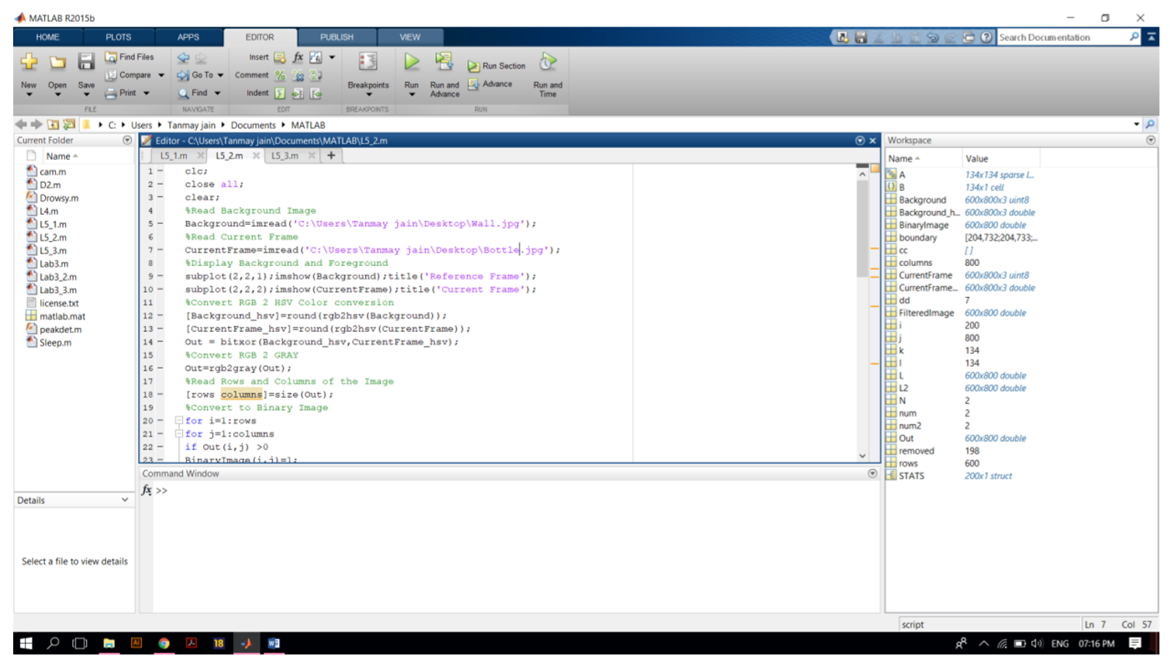

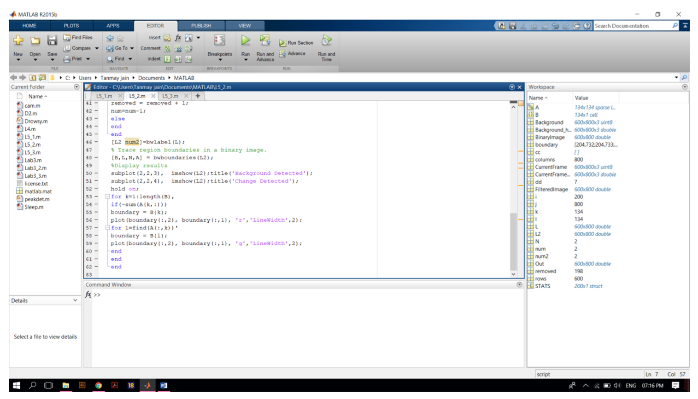

SOLUTION:
